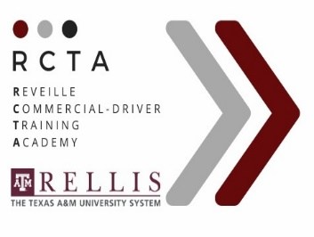
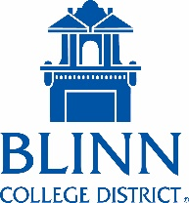

Commercial Driver Skills Training
Pre-Class Requirements

BEFORE TRAINING BEGINS, THE FOLLOWING PRE- REQUISITES MUST BE COMPLETED:

Pass a DOT Physical/ DOT Drug Screen:

IMPORTANT: Contact RCTA to schedule your appointment for the DOT drug screen and physical 979-985-3111 or 936-436-3996.

  - Upon successful completion of the physical, the doctor will provide you with a DOT medical card and long form physical that is good for one or two years, depending on the examination results.

  - Bring this paperwork, the long form physical and DOT medical card, with you when you enroll in the Professional Driver Training Class and provide to RCTA.

- Must schedule appointment with DPS to obtain your Class A learners permit:

You will need to study the below topics.

  - Use the Commercial Motor Vehicle Driver Handbook to Study for The Following Tests
  - Study chapter 14 for Special Requirement
  - Study chapters 1, 2, and 3 for General Knowledge
  - Study chapter 6 for Combination Vehicles
  - Study chapter 5 for Air Brakes
  - Study chapter 8 for Tank Vehicles Endorsement
  - The CDL Permit fee is $25.00. The DPS will issue you a paper permit, you will receive an actual card in the mail, be sure to bring the paper or card to RCTA and have on you at all times during training.
  - Must obtain an AR/ MVR report to submit to RCTA.

Complete the RCTA Pre-Qualification Form available online from Technical and Community Education https://www.blinn.edu/truck-driving or https://www.rctacdl.org

