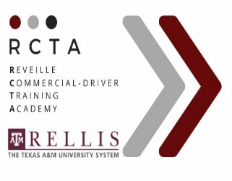
Commercial Driver Skills Training
Pre-Qualification Form

I understand that in completing this qualification form, RCTA is under no obligation to accept me, nor am I under any obligation to RCTA. I agree to furnish all required documents for admission and certify that the information contained in the application for admission is correct. RCTA adheres to practices and policies of equal opportunity in admissions and employment.

Today’s Date: Social Security Number:

Name:

Mailing Address: Street City State Zip Code

Phone Number: Cell Number:

Driver’s License Number: State: Class: Expiration Date:

Date of Birth: Age: Email Address: Sex: Male Female

Marital Status: Are You Currently Working? How Many employers have you had in the last 5 years?

ADMISSIONS INFORMATION | YES | NO | EXPLINATION
1. Do you have a high school diploma? |  |  | We may request a copy if applicable
2. Do you have any careless/ reckless driving  charges in the last 3 years? |  |  | If yes, how many?
3. Have you had any moving violations in the  past 3 years? |  |  | If yes, how many?
4. Have you had any traffic/ vehicle accidents in  the past 3 years |  |  | If yes, when?
5. Have you ever had your driver license  suspended? |  |  | If yes, when?
6. Have you ever been convicted of a DWI or  DUI? |  |  | If yes, when?
7. Have you ever had a misdemeanor  conviction? |  |  | If yes, when?
8. Have you ever had a felony conviction? |  |  | If yes, when?
9. Have you ever had any alcohol/ drug  violations? |  |  | If yes, when?
10. Have you ever held a driver license from any  state other than Texas? |  |  | If yes, when and where?

I have read and understand the entire foregoing application, and all answers, statements, and all other matter therein are true in substance and in fact. I also request an abstract copy of my driving record be forwarded to RCTA.

Signature: Date:

Interview By: _ _ Date: Qualified: _ Not Qualified:

